Name: _____________________ Class:__________ Date:__________
Instructions: Write answers in the right-hand column. Score: ___________ / 50 marks
Section A— Multiple choice (10 marks)

 | Alfred Wegener proposed the theory of continental drift. Which of the following observations did he use to support his theory?  - Fossils could be found in different countries.  - Africa and South America seemed to fit together like jigsaw pieces.  - Rocks had magnetic striping near the ocean ridges.  - The sea floor seemed to be made at the ridges. | B | 1
- 2 | Harry Hess proposed a mechanism by which Wegener’s continental drift could occur. Hess’s theory was called:  - plate tectonics  - continental drift  - seafloor spreading  - subduction | C | 1
- 3 | Magnetite is a magnetic mineral that can be found in basalt, which is common in oceanic crust. Magnetite enabled scientists to obtain evidence of:  - seafloor spreading  - Earth’s magnetic field  - subduction  - tectonic plates | A | 1
- 4 | Rifting is the process of:  - ocean trenches forming by collision of plates  - the crust subducting  - plates moving by sliding past each other  - the crust cracking and subsiding | D | 1
- 5 | Evidence of spreading of the crust at ocean ridges resulted from:  - seismic activity in the Earth’s crust  - differences in density of oceanic and continental crust  - subduction of plates at collision boundaries  - reversals in the Earth’s magnetic field | D | 1
- 6 | Chains of volcanic islands in the sea called an ‘island arc’ provided evidence of which particular process?  - rifting  - seafloor spreading  - subduction  - transform boundaries | C | 1
- 7 | An island chain, such as the Hawaiian Islands, provided evidence for which tectonic process?  - plate movement  - subduction  - collision boundaries  - rifting | A | 1
- 8 | Tectonic plates nowadays can be measured accurately using:  - a tectonic scale  - GPS and satellites  - a seismometer  - microwave and mobile phone technology | B | 1
- 9 | Seismic waves can be used to determine the:  - speed of plate movement  - rate of seafloor spreading  - structure of the Earth  - depth of ocean trenches | C | 1
- 1 | Which of the following is a property of secondary (S) body waves?  S waves:  - travel through both solid and molten rock  - are the fastest-moving body waves  - are transverse waves  - hit the surface with an up-and-down or push-pull motion | C | 1

Section B— Short answer (30 marks)

- ` | Clarify how the distribution of earthquakes and volcanoes can be related to movement at plate boundaries. | Earthquakes and volcanoes are found at plate boundaries.  They occur there because the movement of the plates generates heat and magma that escapes from volcanoes.  Sudden movements of the plates at the boundaries cause earthquakes. | 3
 | Apply your knowledge of what happens when an oceanic plate collides with a continental plate to answer the following questions.  a Explain why the oceanic plate is forced under the continental plate.  b Outline the process of subduction.  c Explain why volcanoes often form on the continental plate after the collision. | a The oceanic plate is denser and sinks below the lighter continental plate.  b Subduction is the sinking of one plate below another. The plate melts and magma is formed, rising up to the surface.  c A volcano is formed where the rising magma from the subduction forces itself through weak areas in the continental crust. | 3
 | Describe the three types of movement of plates at plate boundaries. | Convergent – plates move towards each other.  Divergent – plates move away from each other.  Transform – plates slide past each other. | 3
 | Explain the role of heat and convection in plate movement. | The mantle is very hot and is not completely solid.  The material slowly flows in a convection current with the hot mantle rising to the surface, cooling and then subsiding again.  As the convection current flows across the plates, it is thought to drag them along by friction. | 3
 | Explain why Australia is relatively geologically stable. | Australia is a long way from the boundaries of the plate on which it is moving.  The northern edge of the plate is near Indonesia. The southern boundary is halfway to Antarctica.  Since earthquakes and volcanoes are mainly due to movements near plate boundaries, Australia has much less activity than many other countries that are near the edges of the plates. | 3
 | Describe Hess’s theory of seafloor spreading. | New crust forms at ocean ridges when magma rises up into the rift and solidifies.  The crust steadily moves towards a converging boundary with continents, where it subducts and is destroyed. | 2
 | Clarify what is meant by a destructive and a constructive plate boundary. | A destructive plate boundary is a convergent boundary where one plate subducts and is destroyed.  A constructive plate boundary is a diverging boundary. Here new crust is formed. | 2
 | Explain why there are explosive volcanic eruptions in some places, whereas in others the lava flows out in a fast-flowing stream. | Explosive eruptions occur where the magma is viscous.  This is typically where oceanic crust is destroyed. The minerals in the oceanic crust make it flow more slowly and it traps gas.  The gas suddenly escapes when the rock fractures with explosive force. Where lighter minerals are in the crust, the magma is less viscous. | 3
 | List five pieces of evidence that support the theory of plate tectonics. | Any five of:  - Mid-ocean ridges have magnetic striping – symmetrical either side of the ridges.  - The ocean crust is older the further away it is from the ridges.  - Sediments are thicker the further they are from the ocean ridges.  - Fossil distribution can be made to be continuous across landmasses when they are joined up into Gondwana and Pangaea.  - GPS and satellites show the plates move.  - The same fossils are found in landmasses that are separated by oceans.  - Landmasses seem to fit together like a jigsaw.  - Ocean trenches occur where one plate subducts.  - Mountain ranges occur where plates collide.  - Volcanic islands occur where plates collide.  - Plates move in three different directions – converging, diverging and transform.  - Iceland is widening by a measurable amount each year.  - Most volcanoes occur along the boundaries of tectonic plates.  - Hot spot volcanoes leave an island chain behind as the plate moves. | 5
 | Explain how a tsunami occurs. | Plates at a boundary under the ocean suddenly move.  This creates a wave that spreads out below the surface and at the surface.  At the surface the wave slows and rises up when it reaches shallow water. | 3

Section C— Thinking scientifically (10 marks)

 | Iceland is about 250 km wide and is widening by 2 to 5 cm per year. Assuming an average of 5 cm per year, calculate how long ago Iceland formed.  - 50 million years ago  - 5 million years ago  - 200 million years ago  - 20 million years ago |  | 1
 | If geologists determine that Iceland began to form 12.5 million years ago, what can you deduce?  - The Atlantic Ocean is much older than previously thought.  - The rate of separation of the plates at the ridge is greater than 5 cm per year.  - The magnetic striping evidence must be wrong.  - The rate of seafloor spreading is less than 5 cm per year. |  | 1
 | Australia was once joined to Antarctica. At present the plate boundary is about half way between the two continents, a distance of about 3500 kilometres. The current rate of movement of the plate is 7.5 cm per year. Using this information, calculate how long ago Australia joined to Antarctica.  - 46 million years ago  - 92 million years ago  - 23 million years ago  - 19 million years ago |  | 1
 | Eastern Australia has some extinct volcanoes. The oldest are in Queensland and they become progressively younger all the way down to southern Victoria. The nearest plate boundaries are thousands of kilometres away. Identify which of the following is a likely explanation for these volcanoes.  - They were formed by subduction at a collision boundary along the east coast.  - They were formed by rifting of the crust along the east coast.  - They are hot spot volcanoes from a hot spot south of Victoria.  - A new transform boundary is forming along the east coast. |  | 1
 | Consider the following table:  What do you conclude from this data?  - All parts of a plate move at the same rate.  - Different plates move at the same rate.  - Plates at a diverging boundary move much faster than plates that are colliding.  - The same plate can move at different rates along its boundary. |  | 1
  Pair of plates | Type of boundary | Rate of movement (cm/yr)
  Australian/Antarctic | Diverging | 6.5 in west, 7.5 in south, 6.8 in east
  Pacific/Nazca | Diverging | 17.6
  Pacific/Antarctic | Diverging | 6.2 in west up to 10.2 in north
 | On 26 December 2004, at 8 a.m. local time, a massive earthquake of 9.0 on the Richter scale occurred near the Indonesian city of Banda Aceh. The tsunami that was formed devastated the region and one report said 400 000 people died. The tsunami took about 6 hours to travel the 4125 kilometres to the south-west of Australia. Calculate approximately how fast the tsunami travelling through the water.  - 700 km/hr  - 70 km/hr  - 68 km/hr  - 240 km/hr |  | 1
The following information is for questions 7 to 10.
Consider the following map showing the positions of two GPS ground stations near the city of San Francisco in California, USA. One station is on the Farallon Islands on the Pacific Plate. The other station is east of the Farallon Islands. It is in the city of Columbia, on the North American Plate. The graph shows the direction of movement of the two stations against each other. The horizontal line on the graph shows movement in a westerly direction.
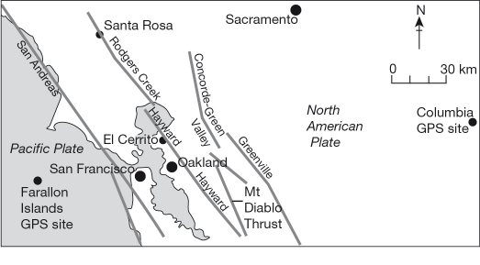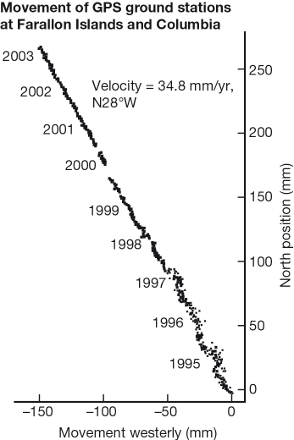
 | what approximate direction does the California coast run?  - north-west  - north  - east  - south-west |  | 1
 | Velocity means speed in a particular direction. What does the information on the graph ‘velocity = 34.5 mm/yr N28°W’ mean?  - The two GPS stations are moving in the same direction at 34.5 mm per year.  - One GPS station is 34.5 mm north-west of the other station.  - One GPS station is moving 34.5 mm in a north-westerly direction compared with the other.  - The two GPS stations are moving north and west compared with San Francisco. |  | 1
 | The graph supports the view that:  - the Pacific Plate is moving towards the North American Plate  - there is a collision boundary between the Pacific Plate and the North American Plate  - a rift is opening between the Pacific Plate and the North American Plate  - there is a transform boundary between the Pacific Plate and the North American Plate |  | 1
 | The information in the map and graph shows that:  - subducting plates can be measured by GPS ground stations  - GPS ground stations can measure the direction and speed of plate movements  - GPS ground stations can predict when a fault line is going to slip  - earthquakes and volcanoes can be predicted using GPS ground stations |  | 1

